Name____________________________________ Homework February 28th -March 4th
Put your initials by each night that your child practiced the following:

_____ Monday _____ Tuesday _____ Thursday

*Nightly Homework*
1. Read the Start Right Reader page.
2. Count numbers 1-75.
3. Practice assigned Sight Word list in red reading folder.

Monday:
Practice writing each spelling word three times.

van zip zap sap lap can yam

_____ _____ _____ _____ _____ _____ _____

_____ _____ _____ _____ _____ _____ _____

_____ _____ _____ _____ _____ _____ _____

Write a word and draw a picture for three words in the -eep word family.
Choose one word and write in a sentence.

__eep

__eep

__eep

______________________________________________________________

Tuesday: Circle the middle sound for each word.

a e i o u
a e i o u

a e i o u
a e i o u

Write the correct initial consonant blend.

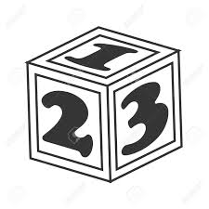

__ __oud __ __ ower __ __ide ____ock

Read the sentence and draw a picture to illustrate.

The red van can go fast.

Start Right
Reader Week of February 28th- March 4th
Directions: Let your child read this to you.

Words to Read
clip snag

stands step

Words to Know
must said

when

Can Ben Get It?
“I must get that,” Ben said. Ben hops and hops. Ben stands on a step, but he can not snag it. Ben must not quit. “Got it!” said Ben. Ben got a rod. Ben fit a clip on the rod. When Ben tips the rod, the clip snags it! Ben did it! At last!

Blend and Read: Read these words. Find these words in the story.
step snag clip

last stands
but that get

Initial each night.
Mon. | Tues. | Thurs.

